**Phase 4: Development part2**

The problem is to build an AI-powered spam classifier that can accurately distinguish between spam and non-spam messages in emails or text messages. The goal is to reduce the number of false positives (classifying legitimate messages as spam) and false negatives (missing actual spam messages) while achieving a high level of accuracy.

**PROBLEM DEFINITION**

Design and create a more intelligent AI-powered classifier that can correctly classify a variety of dynamic datasets using cutting-edge machine learning algorithms. The objective is to develop a robust, adaptable, and effective categorisation system that outperforms current approaches and gives stakeholders useful insights and actionable information.

**Design thinking:**

1. Data gathering

2. Data Cleaning and Preprocessing

3. Feature engineering

4. Model selection

5. Model training

6. Evaluation Metrics

7. Threshold Optimisation

8. Update the model

9. Implement tools

**Before pre-processed dataset**

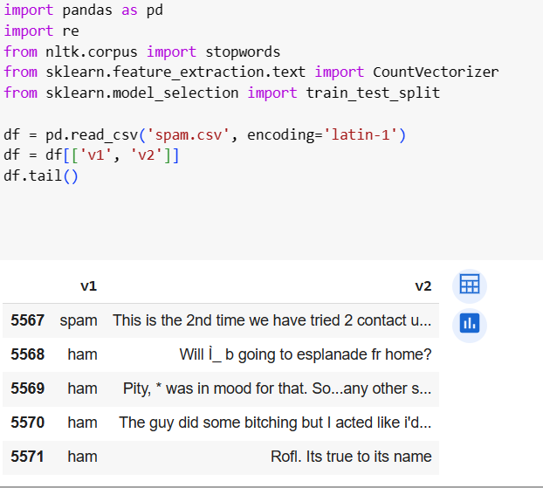

**Feature extraction**

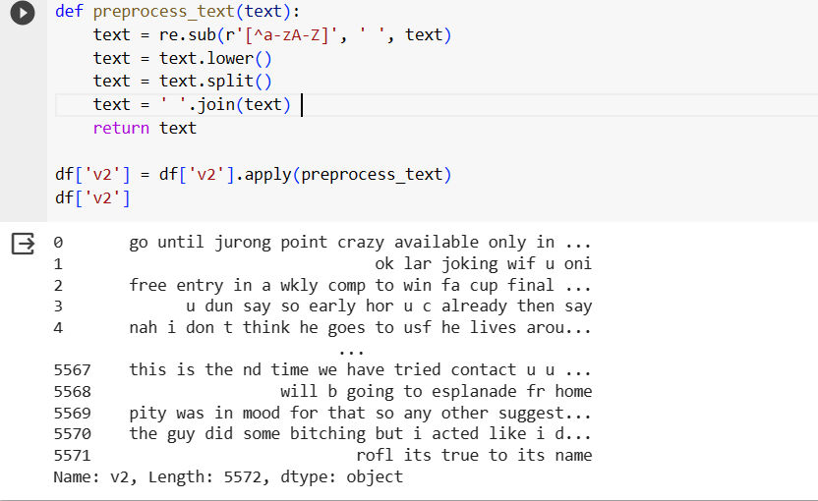

**Model training**

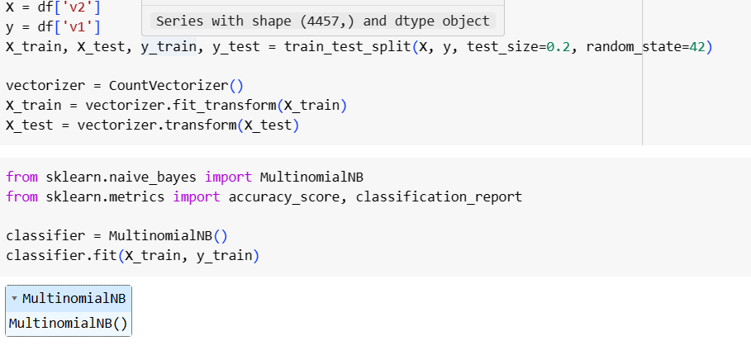**Evaluation the model**

